**Resume Examples and Tips for College Students and Graduates**

**BY**[**ALISON DOYLE**](https://www.thebalancecareers.com/alison-doyle-2058389)Updated June 12, 2019



When you're a college student or recent graduate, it can be a challenge to figure out what to include on your [resume](https://www.thebalancecareers.com/student-resume-examples-and-templates-2063555). After all, most college students don't have an extensive [employment history](https://www.thebalancecareers.com/employment-history-verification-2059609). Employers know that, however, so they don't expect to see a lengthy list of jobs.

But just because you are at the beginning of your career doesn’t mean that you don’t have significant accomplishments to include in your resume. As a college student or recent graduate, you have many achievements that will qualify you for internships, summer jobs, and your first post-graduation position.

Tip: Along with paid employment, you can list [volunteering](https://www.thebalancecareers.com/how-to-include-volunteer-work-on-your-resume-2063297), summer jobs, paid and unpaid [internships](https://www.thebalancecareers.com/how-to-list-an-internship-on-a-resume-4173980), coursework, and school activities on your resume.

You can also highlight the skills that best qualify you for the jobs for which you're applying. Taking the time to [show the employer that you have the right skills](https://www.thebalance.com/top-skills-employers-seek-in-college-grads-4030755) will help get your application considered for an interview.

Read below for advice on [how to write a resume](https://www.thebalancecareers.com/job-resumes-4161923) as a college student or graduate, along with lists of resume examples to review and download to get started on writing your own resume.

### What to Include in Your Resume

If you're not sure what to include, do some brainstorming about all of your past experiences, including work-related positions, volunteering, academic experience, campus leadership positions, extracurricular activities, internships, and any awards or special recognition you may have received. They can all be included on your resume.

Make a list of all you have accomplished during your time at college, and include the achievements that are most relevant to the job you are applying for your resume. You'll need to [tweak your resume each time you apply](https://www.thebalancecareers.com/how-to-tailor-your-resume-for-jobs-2063133), but it's well worth the extra effort.

### Resume Writing Tips for College Students and Grads

#### **Emphasize Academics**

If you have limited work and extracurricular experience, you can emphasize your academic history.

* Put the [“Education” section](https://www.thebalancecareers.com/what-to-include-in-the-education-section-of-a-resume-4169507) of your resume at the top of your resume so that it is the first thing the employer sees.
* Along with the name of your school and degree, include any achievements, such as a high [GPA](https://www.thebalancecareers.com/when-to-include-your-gpa-on-your-resume-2059859) or any academic awards (such as making the Dean’s List).
* If you have taken courses related to the job you’re applying for or completed school projects that required skills related to the job, list those as well.

#### **Match Your Skills to the Job**

Look at the job listing or postings you are applying for — your goal here is to [match your experience](https://www.thebalancecareers.com/how-to-match-your-qualifications-to-a-job-2060941) and skills with the job requirements.

* Circle the experiences and skills on your brainstormed list of experience that relate directly to the job (or jobs) you have targeted.
* Incorporate those circled items into your resume.
* You can elaborate on some of these experiences in a bulleted list under each one.

#### **Highlight Your Achievements**

Based on your experiences, you might choose to divide your resume into [different categories](https://www.thebalancecareers.com/examples-of-each-part-of-a-resume-4060508), such as “Work History,” “Volunteer Experience,” “Relevant Coursework,” and more. If you do not have much relevant experience, you might put all of these under the same category of “Related Experience.”

#### **Create a Skills Section**

You can also create a [“Skills” section](https://www.thebalancecareers.com/what-to-include-in-a-resume-skills-section-2063321) on your resume to highlight skills you have gained throughout your experiences. For example, if you are applying for a job as a computer programmer, you might list the programming languages you are familiar with under the “Skills” section of your resume.

#### **Print Your Resume**

It's much easier to review your resume to check the formatting and catch errors, if you print it out. You'll be able to make sure there is plenty of white space, your resume is readable, and you haven't made any mistakes.

### Resume Examples for College Students and Graduates

Use a resume example or a resume template to guide your own writing. A resume example can help you decide what kind of content to include, as well as how to format your resume. However, be sure to tailor a resume example to fit your own experiences, and the job you are applying for.

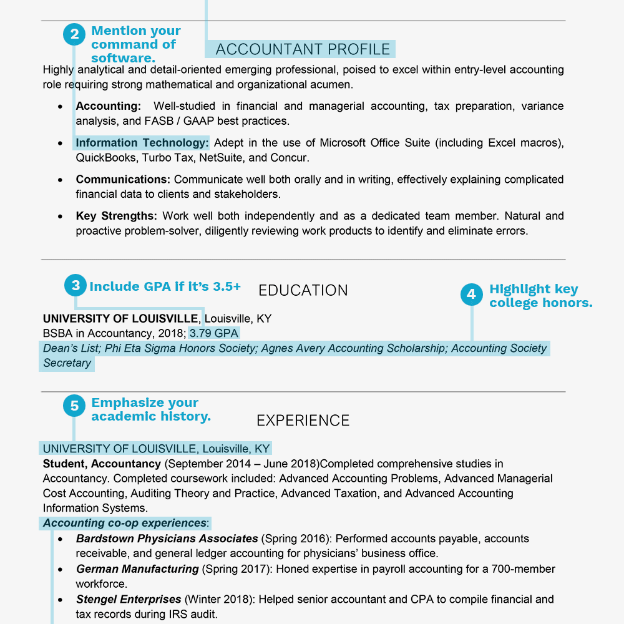

### Resume Example for College Students and Graduates (Text Version)

**Kenneth Applicant**  
8907 Greentree Avenue  
Louisville, KY 40201  
email@email.com (000) 123-4567 (cell)

**ACCOUNTANT PROFILE**

Highly analytical and detail-oriented emerging professional, poised to excel within entry-level Accounting role requiring strong mathematical and organizational acumen.

* **Accounting**: Well-studied in financial and managerial accounting, tax preparation, variance analysis, and FASB / GAAP best practices.
* **Information Technology**: Adept in the use of Microsoft Office Suite (including Excel macros), QuickBooks, Turbo Tax, NetSuite, and Concur.
* **Communications**: Communicate well both orally and in writing, effectively explaining complicated financial data to clients and stakeholders.
* **Key Strengths**: Work well both independently and as a dedicated team member. Natural and proactive problem-solver, diligently reviewing work products to identify and eliminate errors.

**EDUCATION**

BSBA in Accountancy (May 2018); 3.79 GPA UNIVERSITY OF LOUISVILLE, Louisville, KY

Dean’s List; Phi Eta Sigma Honors Society; Agnes Avery Accounting Scholarship; Accounting Society Secretary

**EXPERIENCE**

UNIVERSITY OF LOUISVILLE, Louisville, KY  
**Student ~ Accountancy**, 09/2014-06/2018

Completed comprehensive studies in Accountancy. Completed coursework included: Advanced Accounting Problems, Advanced Managerial Cost Accounting, Auditing Theory and Practice, Advanced Taxation, and Advanced Accounting Information Systems. Accounting co-op experiences:

* **Bardstown Physicians Associates** (Spring 2016): Performed accounts payable, accounts receivable, and general ledger accounting for physicians’ business office.
* **German Manufacturing** (Spring 2017): Honed expertise in payroll accounting for a 700-member workforce.
* **Stengel Enterprises** (Winter 2018): Helped senior accountant and CPA to compile financial and tax records during IRS audit.

OFFICE SUPPLIES CO., Louisville, KY  
**Seasonal Retail Sales Consultant**, Summers 2016 and 2017

Provided attentive customer service to patrons of high-volume office supply store. Helped customers with product selection, stocked shelves, and operated point-of-sale system.

**Key achievements**:

* Earned “Most Valued Associate” two summers in a row.
* Rehired by management in recognition of punctuality, attention to detail, and excellent work ethic.